Division Method
# Source: AI Source: Provided by: [Data Path: Persons Table -> ID Column: 1, Name_En Column: Motasem Essam] -> From: [ChatGPT] on [7/13/2026]
The Division Method is a systematic technique for finding the prime factorization of a composite number by repeatedly dividing it by the smallest possible prime number until the quotient becomes 1.
Unlike the Factor Tree Method, the Division Method does not use a tree diagram. Instead, it uses a sequence of divisions, making it an efficient method for larger numbers.

Definition
# Source: AI Source: Provided by: [Data Path: Persons Table -> ID Column: 1, Name_En Column: Motasem Essam] -> From: [ChatGPT] on [7/13/2026]
The Division Method is a method of expressing a composite number as a product of prime numbers by repeatedly dividing the number by prime divisors until the quotient is
$$1.$$
If
$$n=p_{1}×p_{2}×⋯×p_{k},$$
then repeated division by the prime numbers
$$p_{1},p_{2},…,p_{k}$$
produces the quotient
$$1.$$

Rules for the Division Method

1. Begin with the Given Composite Number
# Source: AI Source: Provided by: [Data Path: Persons Table -> ID Column: 1, Name_En Column: Motasem Essam] -> From: [ChatGPT] on [7/13/2026]
Write the number to be factorized.
Example
Start with
$$60.$$

2. Divide by the Smallest Prime Factor
# Source: AI Source: Provided by: [Data Path: Persons Table -> ID Column: 1, Name_En Column: Motasem Essam] -> From: [ChatGPT] on [7/13/2026]
Always begin by dividing by the smallest prime number that divides the current number exactly.
Example
For
$$60,$$
the smallest prime factor is
$$2. \\ 60÷2=30$$

3. Continue Dividing by Prime Numbers
# Source: AI Source: Provided by: [Data Path: Persons Table -> ID Column: 1, Name_En Column: Motasem Essam] -> From: [ChatGPT] on [7/13/2026]
Keep dividing the quotient by the smallest possible prime number until no longer divisible.
Example
$$30÷2=15 \\ 15÷3=5 \\ 5÷5=1$$

4. Stop When the Quotient Becomes One
# Source: AI Source: Provided by: [Data Path: Persons Table -> ID Column: 1, Name_En Column: Motasem Essam] -> From: [ChatGPT] on [7/13/2026]
The process is complete when the final quotient is
$$1.$$
Example
For
$$60,$$
the last division is
$$5÷5=1.$$

5. Multiply All Prime Divisors Together
# Source: AI Source: Provided by: [Data Path: Persons Table -> ID Column: 1, Name_En Column: Motasem Essam] -> From: [ChatGPT] on [7/13/2026]
The prime numbers used in the divisions form the prime factorization.
Example
Prime divisors:
$$2, 2, 3, 5$$
Therefore,
$$60=2×2×3×5$$
or
$$60=2^{2}×3×5.$$

6. Repeated Prime Factors Can Be Written Using Exponents
# Source: AI Source: Provided by: [Data Path: Persons Table -> ID Column: 1, Name_En Column: Motasem Essam] -> From: [ChatGPT] on [7/13/2026]
Repeated occurrences of the same prime factor may be written with exponents.
Example
Prime divisors:
$$2, 2, 2, 3$$
Therefore,
$$24=2^{3}×3.$$

Examples
# Source: AI Source: Provided by: [Data Path: Persons Table -> ID Column: 1, Name_En Column: Motasem Essam] -> From: [ChatGPT] on [7/13/2026]
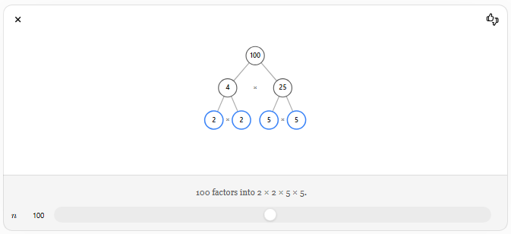
Example 1
Prime factorize
$$24$$
Division:
$$24÷2=12 \\ 12÷2=6 \\ 6÷2=3 \\ 3÷3=1$$
Prime factorization:
$$24=2^{3}×3$$

Example 2
Prime factorize
$$36$$
Division:
$$36÷2=18 \\ 18÷2=9 \\ 9÷3=3 \\ 3÷3=1$$
Prime factorization:
$$36=2^{2}×3^{2}$$

Example 3
Prime factorize
$$48$$
Division:
$$48÷2=24 \\ 24÷2=12 \\ 12÷2=6 \\ 6÷2=3 \\ 3÷3=1$$
Prime factorization:
$$48=2^{4}×3$$

Example 4
Prime factorize
$$72$$
Division:
$$72÷2=36 \\ 36÷2=18 \\ 18÷2=9 \\ 9÷3=3 \\ 3÷3=1$$
Prime factorization:
$$72=2^{3}×3^{2}$$

Example 5
Prime factorize
$$100$$
Division:
$$100÷2=50 \\ 50÷2=25 \\ 25÷5=5 \\ 5÷5=1$$
Prime factorization:
$$100=2^{2}×5^{2}$$

Example 6
Prime factorize
$$210$$
Division:
$$210÷2=105 \\ 105÷3=35 \\ 35÷5=7 \\ 7÷7=1$$
Prime factorization:
$$210=2×3×5×7$$

Algorithm
# Source: AI Source: Provided by: [Data Path: Persons Table -> ID Column: 1, Name_En Column: Motasem Essam] -> From: [ChatGPT] on [7/13/2026]
To find the prime factorization using the Division Method:
- Write the composite number.
- Divide it by the smallest prime number that divides it exactly.
- Write the quotient.
- Repeat the process with the quotient.
- Continue until the quotient becomes 1.
- Multiply all prime divisors together.
- Rewrite repeated prime factors using exponents if desired.

Real-Life Applications
# Source: AI Source: Provided by: [Data Path: Persons Table -> ID Column: 1, Name_En Column: Motasem Essam] -> From: [ChatGPT] on [7/13/2026]
The Division Method is used in:
- Mathematics education
- Simplifying fractions
- Finding the GCD
- Finding the LCM
- Computer science
- Cryptography
- Algorithm design
- Engineering
- Number theory
- Mathematical problem solving

Real-Life Examples
# Source: AI Source: Provided by: [Data Path: Persons Table -> ID Column: 1, Name_En Column: Motasem Essam] -> From: [ChatGPT] on [7/13/2026]
1. Simplifying Fractions
Prime factorization obtained by the Division Method helps identify common prime factors for reducing fractions.

2. Finding the GCD
The Division Method provides the prime factorizations needed to determine the greatest common divisor.

3. Finding the LCM
The least common multiple is obtained by combining the highest powers of all prime factors found by division.

4. Classroom Learning
Students use the Division Method as an organized alternative to factor trees, especially for larger numbers.

5. Computer Programming
Prime factorization algorithms often implement repeated division by prime numbers.

6. Cryptography
Prime factorization techniques are fundamental to understanding the mathematical principles behind public-key cryptography.

Common Mistakes
# Source: AI Source: Provided by: [Data Path: Persons Table -> ID Column: 1, Name_En Column: Motasem Essam] -> From: [ChatGPT] on [7/13/2026]
- Dividing by a composite number instead of a prime number.
- Forgetting to continue dividing by the same prime when possible.
- Stopping before the quotient becomes 1.
- Omitting repeated prime factors.
- Forgetting to write repeated factors using exponents when appropriate.

Key Points
# Source: AI Source: Provided by: [Data Path: Persons Table -> ID Column: 1, Name_En Column: Motasem Essam] -> From: [ChatGPT] on [7/13/2026]
- The Division Method repeatedly divides by prime numbers only.
- Always divide by the smallest possible prime factor first.
- Continue until the quotient equals 1.
- The prime divisors form the prime factorization.
- Repeated prime factors may be written using exponents.
- The Division Method is usually more efficient than the Factor Tree Method for large numbers.

Factor Tree Method vs. Division Method
# Source: AI Source: Provided by: [Data Path: Persons Table -> ID Column: 1, Name_En Column: Motasem Essam] -> From: [ChatGPT] on [7/13/2026]
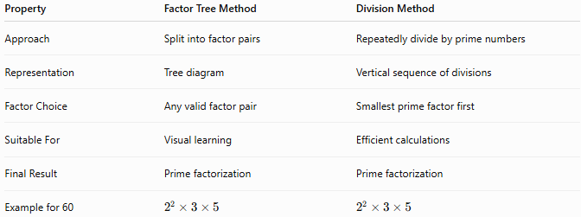
Property | Factor Tree Method | Division Method
Approach | Split into factor pairs | Repeatedly divide by prime numbers
Representation | Tree diagram | Vertical sequence of divisions
Factor Choice | Any valid factor pair | Smallest prime factor first
Suitable For | Visual learning | Efficient calculations
Final Result | Prime factorization | Prime factorization
Example for 60 | $$2^{2}×3×5$$ | $$2^{2}×3×5$$

Conclusion
# Source: AI Source: Provided by: [Data Path: Persons Table -> ID Column: 1, Name_En Column: Motasem Essam] -> From: [ChatGPT] on [7/13/2026]
The Division Method is a systematic technique for finding the prime factorization of a composite number by repeatedly dividing it by the smallest prime divisor until the quotient becomes 1. The prime divisors collected during this process form the unique prime factorization of the number, as guaranteed by the Fundamental Theorem of Arithmetic. This method is widely used in arithmetic, elementary number theory, cryptography, computer science, and applications involving the GCD, LCM, and fraction simplification.

